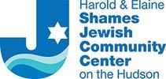
Group Exercise
Effective: Wednesday, November 17, 2021
MONDAY | TUESDAY | WEDNESDAY | THURSDAY | FRIDAY | SATURDAY
8:00am  Mat Pilates  Main Studio  Elena | 8:00am  Aqua H.A.T.  POOL  Yolanda | 8:15am  Hatha Yoga  Main Studio  Bari | 8:00am  Aqua Aerobics  POOL  Yolanda | 7:30am 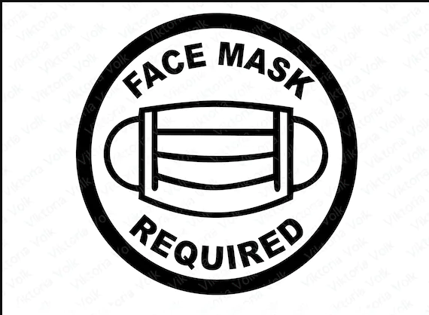  Cycle  Cycle Studio  Guild
9:00am  HIIT  Main Studio  Anna | 8:30am  Cycle  Cycle Studio  Denise | 9:30am  Hi - Lo  Main Studio  Sharon | 8:00am  Yogalates  Main Studio  Elena | 8:30am  Hatha Yoga  Main Studio  Bari | 8:30am  Cycle  Cycle Studio  Tamicka
9:45am  Zumba  Gymnasium  Yolanda | 9:30am  Define  Main Studio  Tamicka | 10:30am  Fit 4 Life  Gymnasium  Deirdre | 9:00am  Cycle  Cycle Studio  Tamicka | 9:30am  Pure Strength  Main Studio  Gina | 9:30am  Kick It  Main Studio  Tamicka
11:45am  Aqua Arthritis  POOL  Steven | 10:30am  Senior Strength &  Conditioning  Gymnasium  Guild | 11:45am  Aqua Arthritis  POOL  Nacho | 10:30am  Senior Strength &  Conditioning  Gymnasium  Guild | 10:30am  Zumba Gold  Gymnasium  Yolanda | 11:15am  Aqua Aerobics  POOL  Tamicka  (Starting November 13th)
 | 4:30pm  Gentle Yoga  Main Studio  Lisa |  | 4:30pm  Slow Flow Yoga  Main Studio  Sadari | 11:45am  Aqua Arthritis  POOL  Tamicka | SUNDAY
5:30pm  F.I.T.  Main Studio  Anna | 5:45pm  Pure Strength  Main Studio  Susan | 5:30pm  Define  Main Studio  TBD | 5:30pm  HIIT  Main Studio  Sadari |  | 8:30am  Cycle  Cycle Studio  Gina
6:15pm  Cycle  Cycle Studio  TBD | 6:45pm  Cycle  Main Studio  Susan | 6:15pm  Cycle  Cycle Studio  TBD | 6:30pm  Cycle  Cycle Studio  TBD |  | 9:30am  HIIT  Main Studio  Gina

CLASS DESCRIPTIONS

CARDIO / STRENGTH:
Cardio Circuit: This intense circuit class combines a mix of cardio and intense muscle work.
Cycle: Pedal through hill climbs, sprints, intervals and other challenging drills in this indoor class.
Define: This strength only class incorporates weights and bodyweight exercises to strengthen your bones. (Not a cardio workout)
F.I.T.: Full body interval training includes a variety of equipment to give a total body workout. This challenging resistance workout combined with intense cardio bursts.
Fit 4 Life: This arthritis fitness class incorporates sitting or standing positions to improve posture, balance, mobility and core strength.

HIIT: High Intensity Interval Training is a training technique that gives you an increased burst of exercise, followed by a short recovery period.

Hi-Lo Sculpt: This class blends step aerobics with body strengthening exercises.

Kick It: It includes high intensity interval training with some kickboxing, boxing
and strength training components. All levels are welcome.

Pure Strength: This total body workout will include resistance training and core work.
Senior Strength & Cardio: This low impact workout consists of a warm-up, cardio, strength and flexibility components geared towards active older adults.

Zumba Gold: Active older adults
who are looking for a modified
Zumba class at a low impact
intensity.

Zumba: Latin-inspired, cardio-dance workout at an upbeat tempo pace.

STRETCH & MOBILITY:
Gentle Yoga: This beginning level class combines yoga postures, breathing and meditation.
Hatha Yoga: A multi-level strength based practice which incorporates a series of poses that flow through breath and movement.

Mat Pilates: This class improves flexibility, tones muscles, helps
balance the body while strengthening the spine and core which helps
promote mind-body awareness.

Yogalates: A combination of Yoga
and Pilates that focus on developing muscular and core strength while improving flexibility.

AQUA CLASSES:

Aqua Aerobics: Develops your coordination, muscular strength, and cardiovascular endurance while
working against shallow water currents to constantly challenge the core muscles, leading to improvements in balance as well.

Aqua Arthritis: Uses water walking and Arthritis Foundation exercises to move all major joints and facilitate activities of daily living. Improve balance, strength, and endurance while having fun in our 89
degree training pool.

Aqua H.A.T.: Targets your core while focusing on training the abdominal and lower back muscles. By using the legs
in multi-dimensional movement patterns, you will develop a stronger midsection to stabilize your torso and improve your balance and posture.

NOTES:

-ACTIVE OLDER ADULT CLASSES
-AQUATIC CLASSES

- FACE MASK REQUIRED

- Reservations required for AQUA and
Cycle Classes

For comments or concerns contact: avazquez@shamesjcc.org
425 S. Broadway | Tarrytown, NY 10591 | 914.366.7898

